Homework answers 9.2.24
- 48 divided by 3 = 16
STEP 1 - 30 divided by 3 = 10
STEP 2 - 18 divided by 3 = 6
STEP 3 - 10 + 6 = 16
- 96 divided by 4 = 24
- 65 divided by 5 = 13
- 45 divided by 3 = 15
- 57 divided by 3 = 19
- 92 divided by 4 = 23

Quick 10 9.2.24
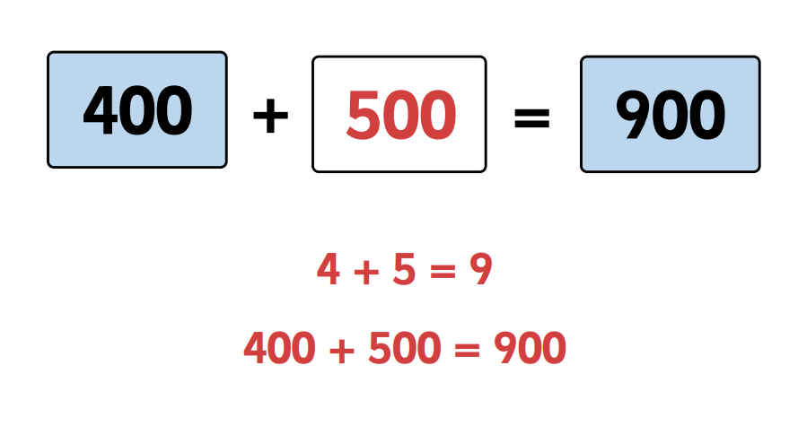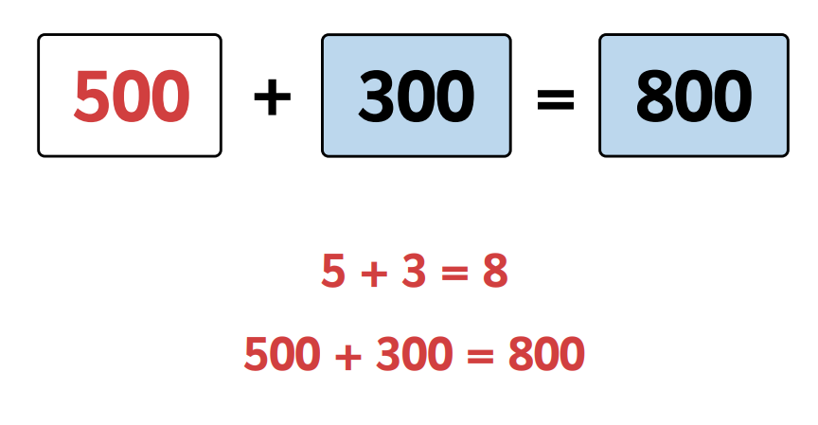
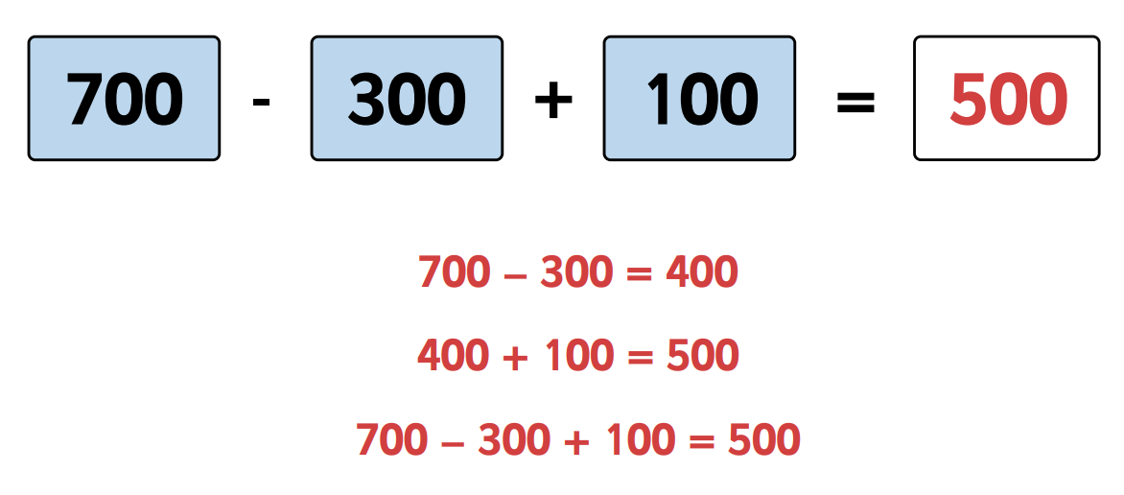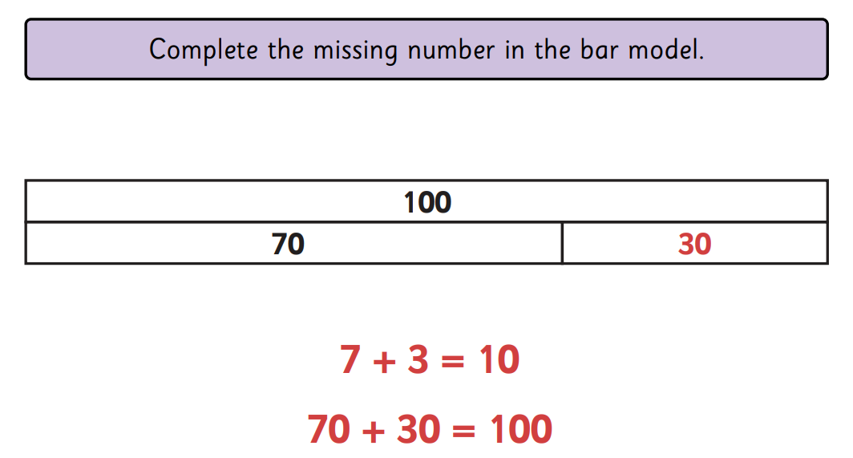
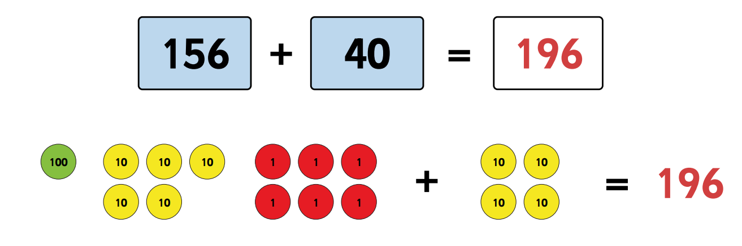
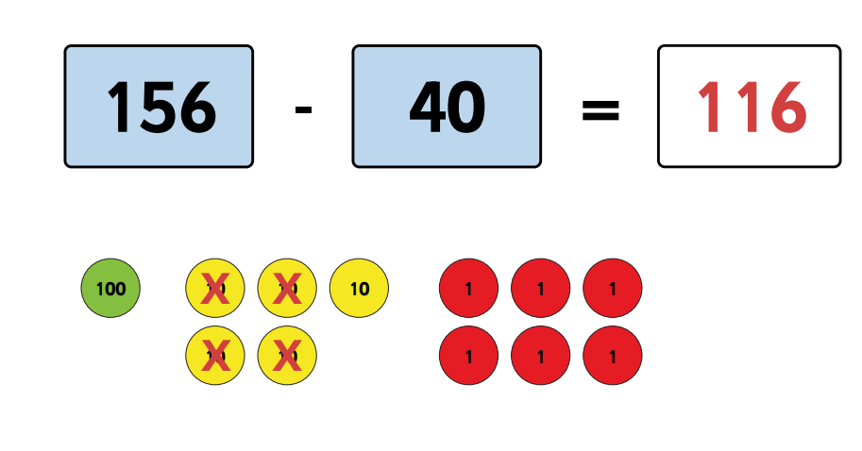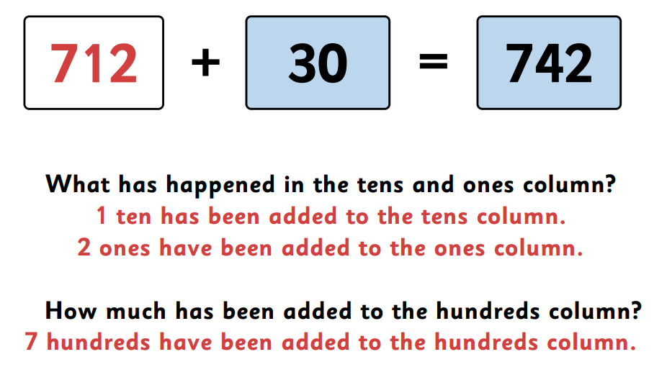
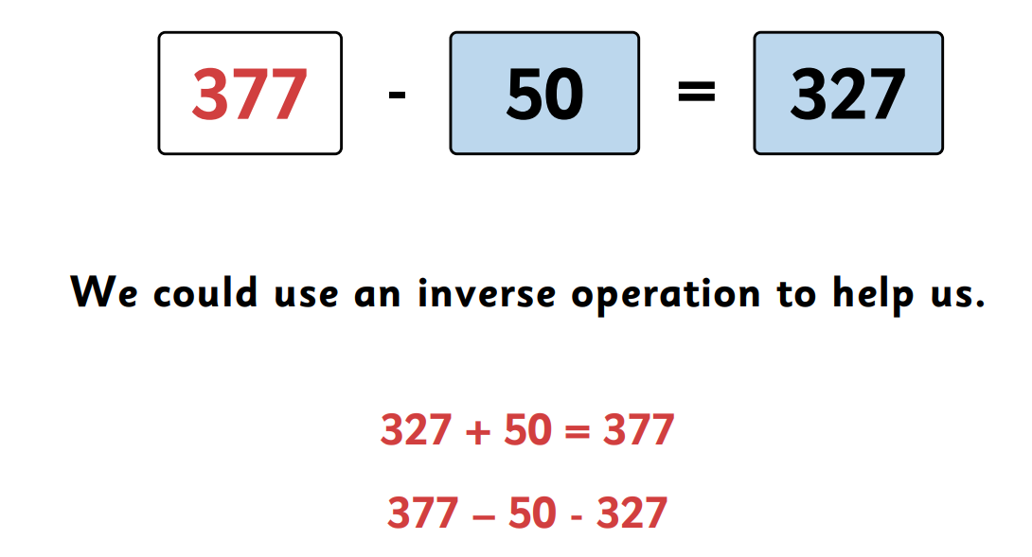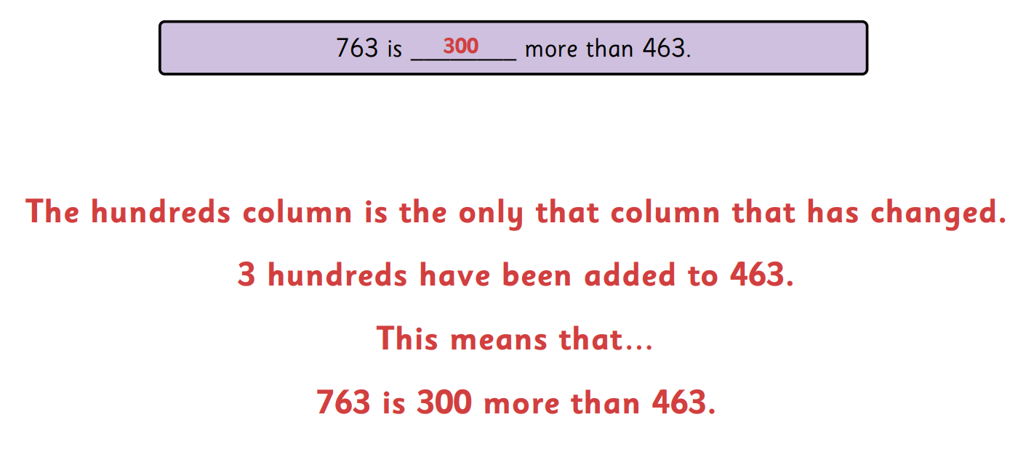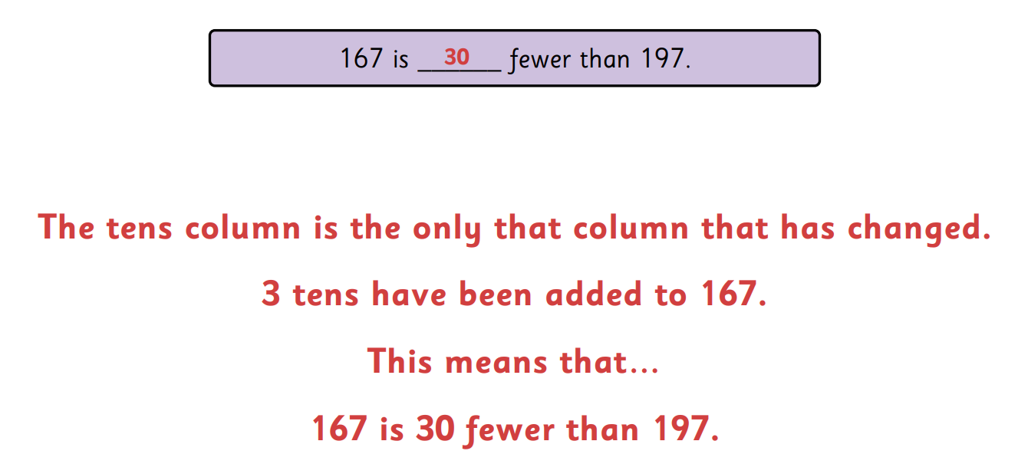

SPAG
- Although and because
- and
- if

